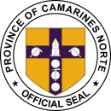[Your Name]

[Your Address] [City, State, ZIP] [Email Address]

[Phone Number] [Date]

Museo Bulawan

3 Justo Lukban St, Daet, 4600 Camarines Norte, Philippines

PROVINCE OF CAMARINES NORTE

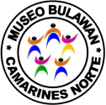**MUSEUM, ARCHIVES AND SHRINE CURATION DIVISION**

**Subject:** Request for Meeting at Museo Bulawan

Dear Museo Bulawan,

I hope this letter finds you well. I am writing to request a meeting with a representative from Museo Bulawan to discuss a [specific purpose or topic] that I believe would greatly benefit from your expertise and insights.

I kindly request your assistance in arranging this meeting, and I am open to the following instructions:

1. Meeting Date and Time: Please provide me with available dates and time slots for the meeting. I am flexible and willing to accommodate your schedule to ensure a convenient time for both parties.
2. 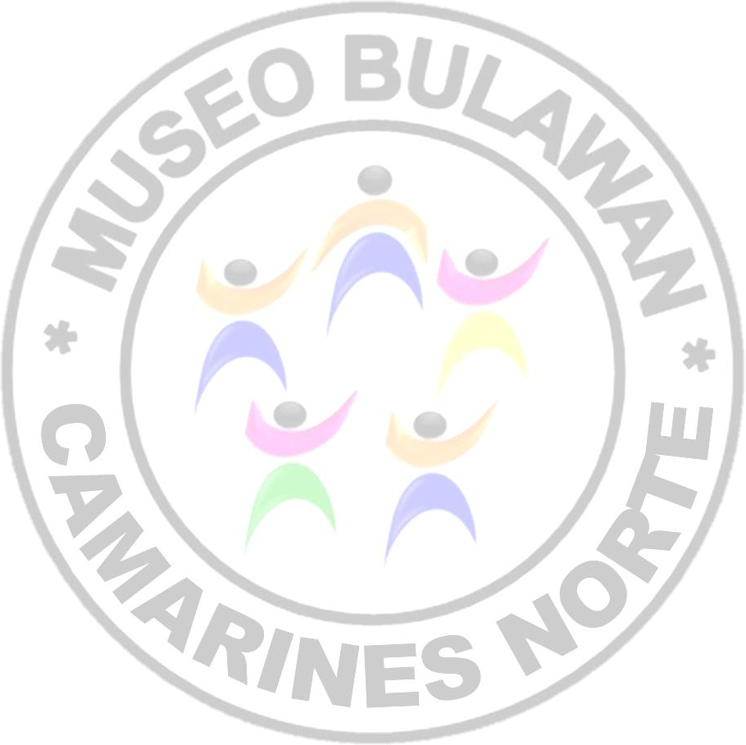Meeting Format: Kindly inform me of your preferred meeting format, whether it be an in-person meeting at Museo Bulawan or a virtual meeting conducted via video conference. Please specify any technical requirements or platforms to be used for the virtual meeting, if applicable.
3. Meeting Agenda: To ensure a productive and focused discussion, I kindly request a brief outline or agenda for the meeting. Please let me know if there are specific topics or areas of focus you would like to cover during our discussion. Additionally, if there are any documents or materials that I should review in advance, please provide them or inform me of where I can access them.
4. Attendees: If there are additional individuals from Museo Bulawan or any relevant stakeholders whom you recommend inviting to the meeting, kindly provide their names and contact information. I am open to ensuring that all necessary parties are involved for a comprehensive discussion.

Thank you in advance for considering my meeting request. I am eager to collaborate with the knowledgeable individuals at Museo Bulawan and explore potential areas of synergy for our mutual benefit.

Please feel free to contact me at [Your Email Address] or [Your Phone Number] to discuss any details or to provide further information. I eagerly await your response and the possibility of scheduling a meeting at Museo Bulawan.

Yours sincerely, [Your Name]